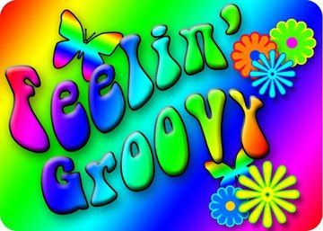  - “back 2 70’s” Emery bay  August 12-15 2021  Flathead Valley Intergroup invites you to Campout:  Thursday August 12 & Friday August 13  - Dinner on your Own & 7 pm Fireside Meeting  Saturday August 14  - 6 pm Ribs & Chicken Potluck  - 8 pm Game & Guest Speaker – John G from New Hope  Sunday August 15  - 8:30 am Breakfast Potluck (everyone bring breakfast meat, eggs, pancake mix, potatoes or fave dish)  - 10:00 a.m. Guest Speaker – Levi S from the Missoula Group  - Tear Down & Checkout by NOON SUNDAY  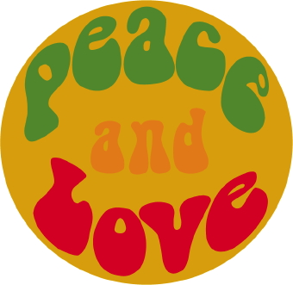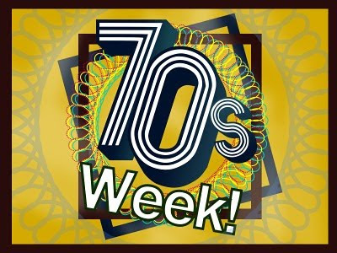  This Photo by Unknown Author is licensed under CC BY-ND  This Photo by Unknown Author is licensed under CC BY-NC-ND | Fun, play & fellowship on the Reservoir!  ____  Check in Thursday 8/12 @ 2pm  ____  *Dogs must be on leash* Bring your own Chair. Bears in area, use precaution.  ____  Located at the Hungry Horse Reservoir  ____  **Volunteers Needed ** Contact Holly B. 471-3836  Jerry H. 210-0519  Group Campsite Fee per night  $13-16 & $5 if more than 1 vehicle per site.  Store Food In Vehicles!!!

